Name: Akshat Bhargava

Rollno: TEAD-22563

DS (SL-III)

Practical 12

Problem Statement: Write a simple program in SCALA using Apache Spark framework

Code:

Install Java:

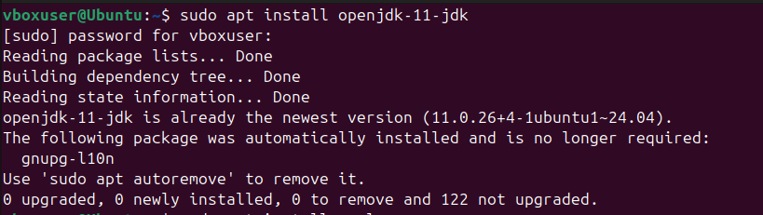

Install Scala:

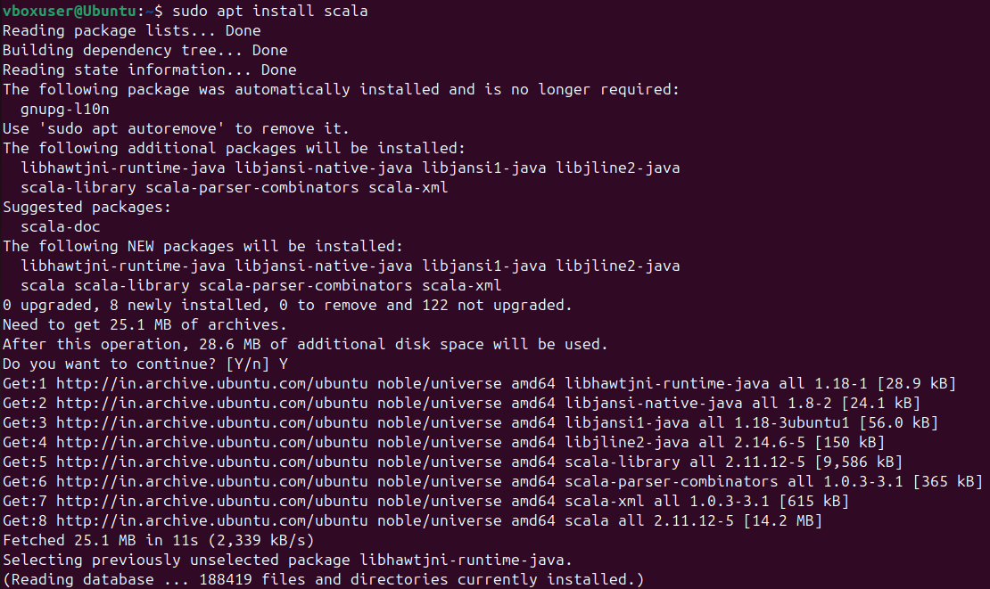

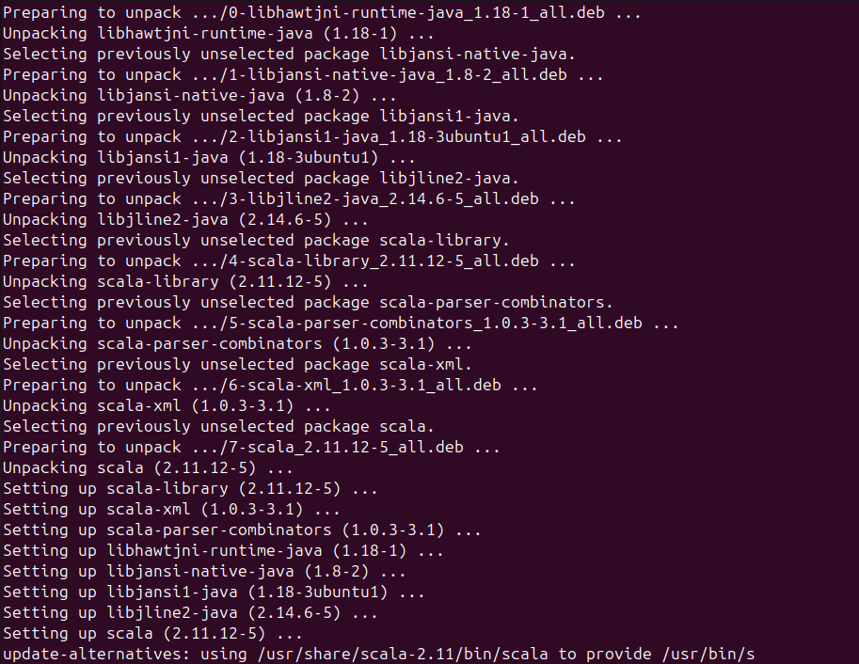

Create a .scala file and write the code:

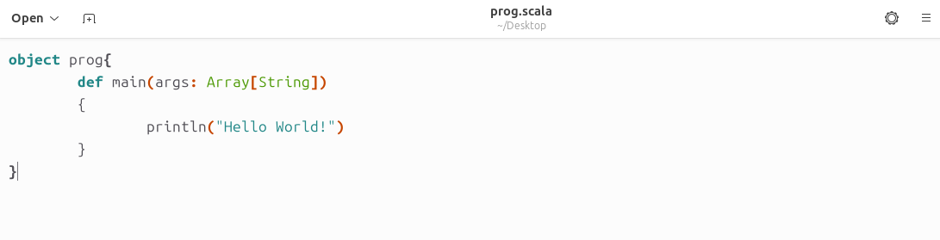

Compile the prog.scala file in terminal:

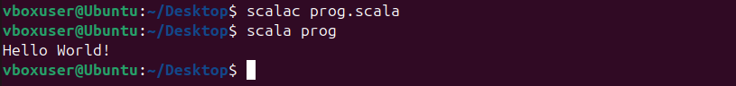

After compiling, you will get prog.class as an output in the same directory:

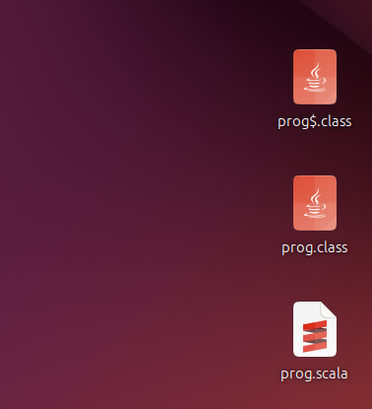

Run the program using following command:

